NOT FOR RELEASE, PUBLICATION OR DISTRIBUTION IN, INTO OR FROM THE UNITED STATES, AUSTRALIA, CANADA OR JAPAN

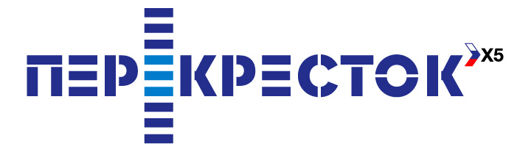 |  |  | 
PRESS RELEASE

PEREKRESTOK BEGINS SALES OF 2008 CLUB CARDS

Moscow, April 4, 2008 – Perekrestok has begun sales of its 2008 Club Perekrestok cards as part of its customer loyalty program.

The loyalty bonus program has been available in all Moscow and Moscow region stores since November 2006. Over 500,000 customers have joined the program since its launch.

When Club cardholders make purchases, they earn bonus points on their account that can be used to pay for any products at Perekrestok stores.

Additional gift points are available for certain types of purchases, including:

- Morning purchases of over 500 rubles
- Perekrestok private label products
- Purchases made on a customer’s birthday

Regular promotions are held for Club Perekrestok cardholders. As part of the program, a list of goods on which cardholders receive bonus points worth 10 percent of the value of the items.is published every two weeks.

There are also regular holiday and gift promotions that offer cardholders a chance to receive significant economic benefits. Together with X5’s partners, cardholders can participate in raffles of valuable prizes and gifts. After joining the Club, customers can “pay” for whatever products they want by using the points that they’ve earned.

The Club package includes two plastic cards: the primary card (which can be used to earn or spend points) and a secondary card (which can only be used to earn points). Cards can be used to earn points immediately upon purchase. When a Club card is purchased, it comes with “welcome” points on it.

In 2007, cardholder purchases accounted for 20.1 percent of all sales at Perekrestok stores in Moscow and the Moscow region.

Karina Chernikova, X5 Retail Group’s Marketing and Advertising Director, said,

“The results of our customer loyalty program in 2007 clearly demonstrate that we were able to overcome thedifficulties associated with the program’s launch. We have optimized the program’s organizational and technical management structure and eliminated the elements that didn’t work out. As a result, the number of technical glitches has dropped dramatically and the program has become more flexible in meeting our clients’ needs.

“We are regularly studying our customers’ opinions and it is clear that they want new and interesting promotions and economically beneficial offers. We have noticed that the number of customers satisfied with the program is constantly risin. And it is still the beginning.

“Changes that we are implementing will be comprehensive, interesting and beneficial, aimed at giving the Club’s significantly broader opportunities,” she added..

You can find more detailed information about the Club Perekrestok customer loyalty program at www.x5club.org.

For further details please contact
Anna Kareva  IR Director  Tel.: +7 (495) 980-2729, ext. 22 162  e-mail: anna.kareva@x5.ru | Elena Cherkalova  PR Manager  Тел.: +7 (495) 950-5577  e-mail: elena.cherkalova@x5.ru

Note to Editors:

X5 Retail Group N.V. is Russia's largest food retailer in terms of sales. The Company was created as a result of a merger between Pyaterochka (soft discounter chain) and Perekrestok (supermarket chain) on 18 May 2006.

As of 31 December 2007, the Group had 674 Company managed soft discount stores located in Moscow (309), St. Petersburg (244) and other Russian areas (121), 179 Company managed supermarkets across Central Russia and Ukraine, including 105 stores in Moscow (Moscow region and Yaroslavl region), and 15 Company managed hypermarkets.

As of 31 December 2007, X5’s franchisees operated 688 stores across Russia and Kazakhstan.

The Group’s net sales for the full year 2007 reached USD 5,320 mln, an increase of 53% year-on-year. Gross profit for the period totaled USD 1,404 mln, EBITDA amounted to USD 479 mln. Full year 2007 net income reached USD 141 mln.

Forward looking statements:
This announcement includes statements that are, or may be deemed to be, “forward-looking statements”. These forward-looking statements can be identified by the fact that they do not only relate to historical or current events. Forward-looking statements often use words such as” anticipate”, “target”, “expect”, “estimate”, “intend”, “expected”, “plan”, “goal” believe”, or other words of similar meaning.

By their nature, forward-looking statements involve risk and uncertainty because they relate to future events and circumstances, a number of which are beyond X5 Retail Group N.V.'s control. As a result, actual future results may differ materially from the plans, goals and expectations set out in these forward-looking statements.

Any forward-looking statements made by or on behalf of X5 Retail Group N.V. speak only as at the date of this announcement. Save as required by any applicable laws or regulations, X5 Retail Group N.V. undertakes no obligation publicly to release the results of any revisions to any forward-looking statements in this document that may occur due to any change in its expectations or to reflect events or circumstances after the date of this document.

