NOT FOR RELEASE, PUBLICATION OR DISTRIBUTION IN, INTO OR FROM THE UNITED STATES, AUSTRALIA, CANADA OR JAPAN

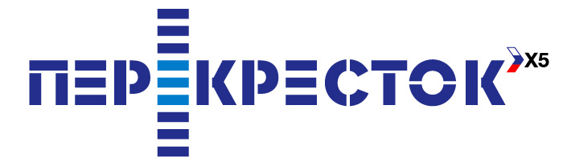 |  |  | 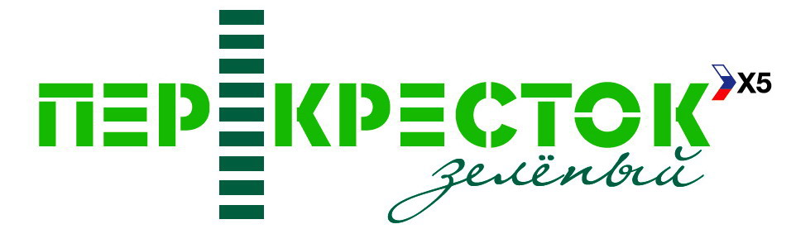
PRESS RELEASE

X5 RETAIL GROUP TO LAUNCH NEW PREMIUM SUPERMARKET
CONCEPT UNDER THE “GREEN PEREKRESTOK” BRAND

Moscow, April 1, 2008 – X5 Retail Group N.V., Russia’s largest food retailer by sales volume, announced the launch of a new premium-class supermarket concept under the “Green Perekrestok” brand name. The first branded store is scheduled to open in July 2008.
Green Perekrestok supermarkets will offer a high level of service and a unique assortment of products that target customers with discriminating tastes. The main competitive advantages of Green Perekrestok supermarkets will be the opportunity to purchase both everyday necessities and select exclusive goods. Customers will be offered a wide assortment of high-quality prepared foods and a broad range of additional services, including individual consultations for gourmet products such as cheese, fish, meat, wine and liquor. The stores will have their own bakeries and delis, and at checkout purchases will be bagged for the customers.

In commenting about the launch of Green Perekrestok, X5 Retail Group’s Chief Operational Officer Antonio Melo said:

“Thanks to the impressive development of the Russian economy over the last several years, the prosperity of many Russians has grown steadily, and this indisputably positive factor enables us to extend our service offering, in line with our multi-format strategy. According to estimates, there are thousands of consumers in the premium goods segment in large cities and individual regions. We are launching the Green Perekrestok project with these customers in mind. The premium class format has only recently emerged in the Russian market, but it is already successful and we intend to take a leadership position in this segment as well, through the Green Perekrestok supermarket concept. We aim to build strong customer loyalty by offering a high level of service, a broad assortment of exclusive products, conveniently located stores, and a distinguished contemporary design in the stores that creates a warm and comfortable atmosphere.”

The first Green Perekrestok store will open in Rostov-on-the-Don in the Astor Plaza shopping center, where an existing Perekrestok supermarket will be re-branded. The new store’s selling area will be 1,400 sq. m. and the product assortment will include approximately 14,000 SKUs.
In the future, new premium class supermarkets will be opened after either re-branding existing Perekrestok stores or acquiring new spaces.

For further details please contact
Anna Kareva  IR Director  Tel.: +7 (495) 980-2729, ext. 22 162  e-mail: anna.kareva@x5.ru | Elena Cherkalova  PR Manager  Тел.: +7 (495) 950-5577  e-mail: elena.cherkalova@x5.ru

Note to Editors:

X5 Retail Group N.V. is Russia's largest food retailer in terms of sales. The Company was created as a result of a merger between Pyaterochka (soft discounter chain) and Perekrestok (supermarket chain) on 18 May 2006.

As of 31 December 2007, the Group had 674 Company managed soft discount stores located in Moscow (309), St. Petersburg (244) and other Russian areas (121), 179 Company managed supermarkets across Central Russia and Ukraine, including 105 stores in Moscow (Moscow region and Yaroslavl region), and 15 Company managed hypermarkets.

As of 31 December 2007, X5’s franchisees operated 688 stores across Russia and Kazakhstan.

The Group’s net sales for the full year 2007 reached USD 5,320 mln, an increase of 53% year-on-year. Gross profit for the period totaled USD 1,404 mln, EBITDA amounted to USD 479 mln. Full year 2007 net income reached USD 141 mln.

Forward looking statements:
This announcement includes statements that are, or may be deemed to be, “forward-looking statements”. These forward-looking statements can be identified by the fact that they do not only relate to historical or current events. Forward-looking statements often use words such as” anticipate”, “target”, “expect”, “estimate”, “intend”, “expected”, “plan”, “goal” believe”, or other words of similar meaning.

By their nature, forward-looking statements involve risk and uncertainty because they relate to future events and circumstances, a number of which are beyond X5 Retail Group N.V.'s control. As a result, actual future results may differ materially from the plans, goals and expectations set out in these forward-looking statements.

Any forward-looking statements made by or on behalf of X5 Retail Group N.V. speak only as at the date of this announcement. Save as required by any applicable laws or regulations, X5 Retail Group N.V. undertakes no obligation publicly to release the results of any revisions to any forward-looking statements in this document that may occur due to any change in its expectations or to reflect events or circumstances after the date of this document.

