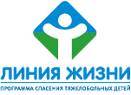

X5 Retail Group N.V.
PRESS RELEASE

X5 HELPS CHILDREN with SERIOUS diseases

Moscow, May 2, 2007 – X5 Retail Group, Russia’s largest food grocery retailer in terms of sales, announced today the provisional results of a program that was promoted in Perekrestok stores. The program was held together with the Russian Charity Program Liniya Zhizni (Lifeline), which is devoted to saving seriously ill children.

Over the course of the program, donation boxes were placed in 50 Perekrestok stores in Moscow to collect money for saving children with heart defects or brain damage. Over 1,390,000 rubles have been collected since October 2006.

“The goal of this program was to show people that ‘a little can go a long way’ and that you do not need to be a very rich person to save the life of a child. Even 10 rubles makes a difference,” said Faina Zakharova, the director of Liniya Zhizni.

With this money, expensive operations have already been successfully made on seven seriously ill children:
Anna Golovkina, born in 2006, from Kostorma. Diagnosis: congenital vascular pathology of the brain;
Natalya Yanokova, born in 2000, from Erkin-Khalk. Diagnosis: congenital heart defect (open arterial duct);
Nikolai Nemnonov, born in 1992, from Moscow. Diagnosis: congenital heart defect (interatrial septum defect);
Ilya Gudkov, born in 1998, from Moscow. Diagnosis: congenital heart defect (interatrial septum defect);
Anna Golukova, born in 1998, from Krasnoyarsk. Diagnosis: congenital heart defect (interatrial septum defect);
Daniila Shamin, born in 2006, from Tverskaya Oblast. Diagnosis: congenital vascular pathology of the brain (vein of Galen malformation);
Lyudmila Yarkova, born in 2001, from Moscow. Diagnosis: congenital heart defect (open arterial duct).

“This is only the first step in our partnership with Liniya Zhizni,” said Yuri Kobaladze, X5 Retail Group Corporate Affaires Managing Director, member of the Advisory Council for the Liniya Zhizni program. “We plan on including Pyaterochka stores in this program, as well.”

“It’s recently become fashionable to talk about social responsibility in business,” said Svetlana Sorokina, a well-known television host and a member of the Advisory Council for the Liniya Zhizni program. “When you have your own child, you always think of how his life will develop. And in our country, I’d like to see as many companies as possible that can help provide assistance and hope in extreme situations so that sick children’s lives can also develop.”

“X5 Retail Group’s managers actively support Liniya Zhizni,” said Yuri Kobaladze. “During the most recent monthly extended management meeting at X5, they took part in the ‘Red Nose – Good Heart’ promotion. All top managers, including the company’s CEO, brought donations and donned red clown noses as a symbol of their work to save seriously ill children. The picture below may soon be displayed in X5 stores and we hope it will make an impression not only on our collective identity, but also become an example for other representatives of the business community.”

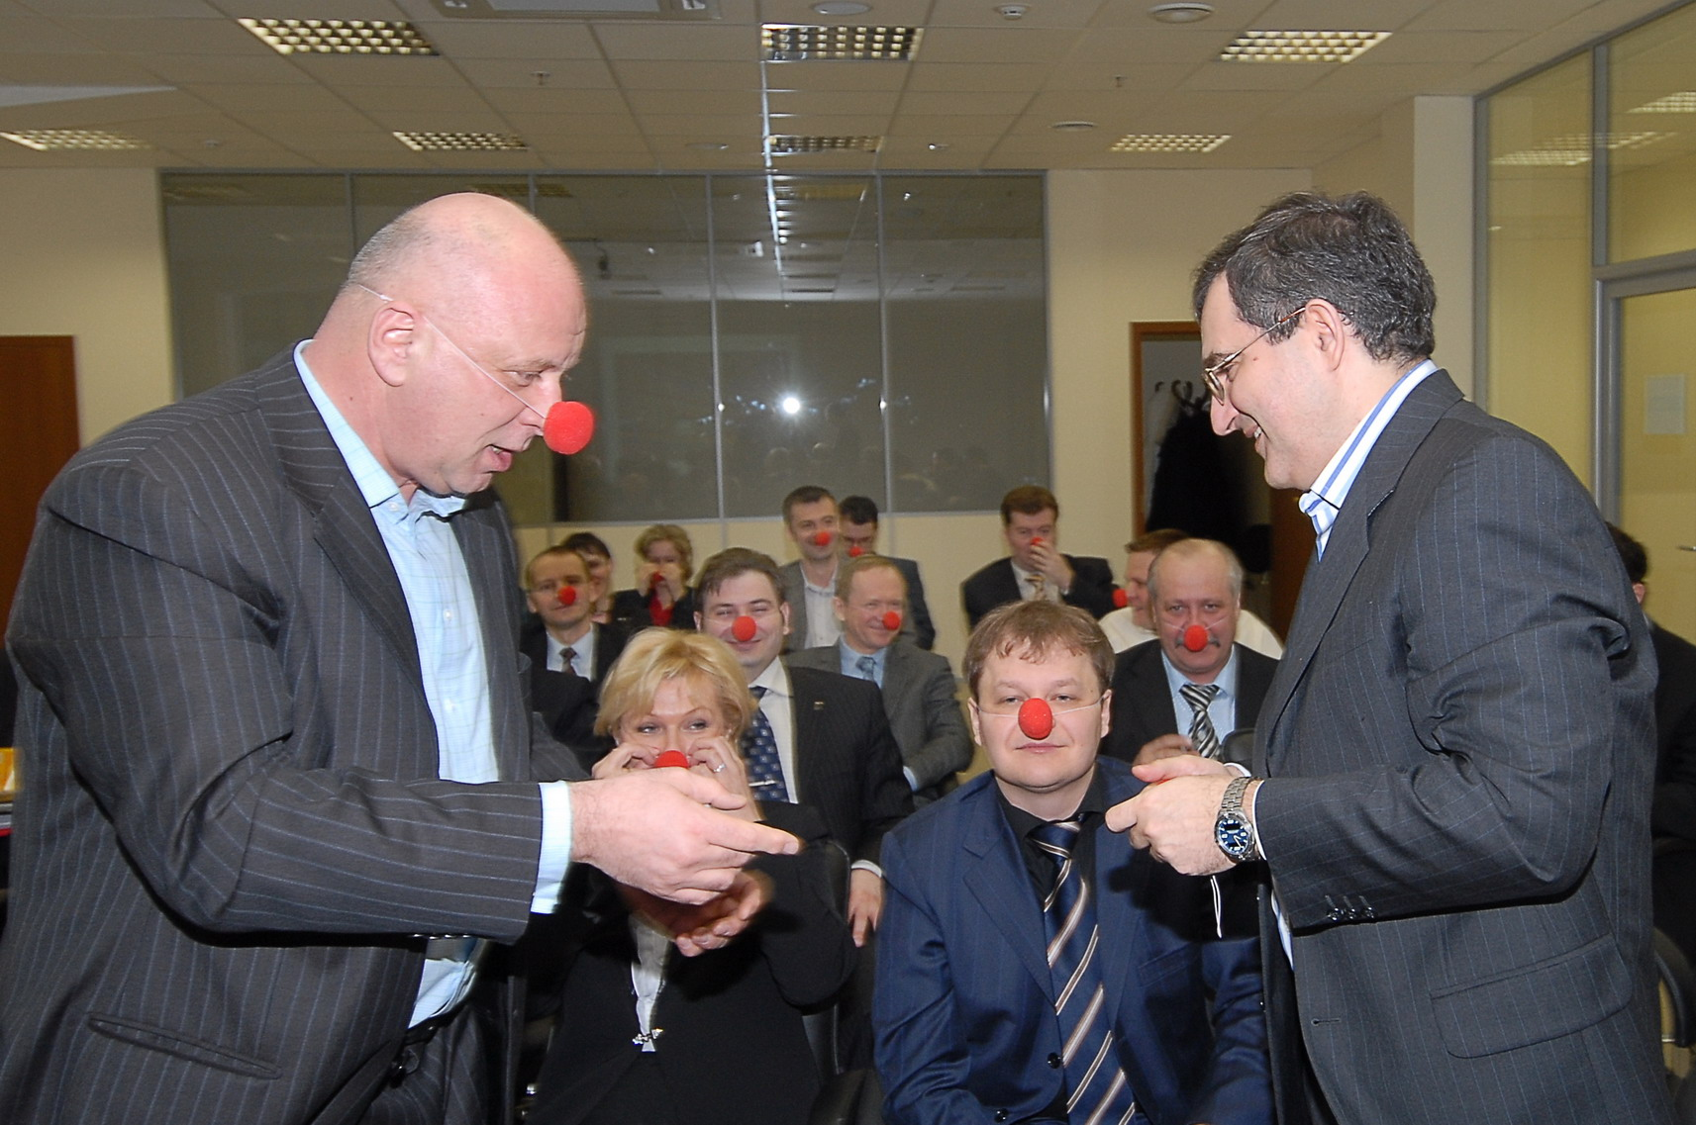

X5 Retail Group CEO Lev Khasis and Corporate Affaires Managing Director Yuri Kobaladze during the ‘Red Nose – Good Heart’ promotion.

Note for editors:

X5 Retail Group N.V. - is Russia's largest food retailer in terms of sales. As of 31 March 2007, the Group had 512 company-managed "Pyaterochka" soft discount stores located in the Moscow (232), St. Petersburg (215) and other Russian areas (65), and 169 company-managed "Perekrestok" supermarkets across Central Russia and Ukraine, including 99 stores in Moscow.

As of 31 March 2007, franchisees operated 533 Pyaterochka branded stores across Russia and Kazakhstan. Perekrestok had 10 stores operated by franchisees in the Moscow area.

Pyaterochka and Perekrestok have merged their operations as of 18 May 2006 to create the clear leader in the Russian food retail market.

The Group’s audited pro forma net sales for the FY 2006 were US $3,551 million, up +50% vs. 2005. Pyaterochka chain provided US $1,973 million of net sales, the Perekrestok chain contributed US $1,496 million of net sales, and Merkado chain contributed US $ 82 million.

Liniya Zhizni charity program for saving seriously ill children – founded on June 1, 2004 to provide ‘directed’ assistance by paying for technologically advanced operations and acquiring special equipment needed to guarantee a better result for curing every individual child.
The program’s goal is to reduce child mortality from serious heart and brain defects that are treatable using modern medicine.
Liniya Zhizni has saved 1315 children in Russia since it was launched. It has collected over $5.5 million for operations. All money donated to Liniya Zhizni is used exclusively for treating ill children.

For additional information please visit: www.x5.ru , www.life-line.ru

Alexandra Galimova, Head of PR, X5 Retail Group
Tel.: +7 (495) 950-5577; e-mail: alexandra.galimova@x5.ru

Polina Gerasimova, PR and Media Relations Coordinator, Liniya Zhizni Program
Tel.: +7 (916) 811-1571, 792-59-29; e-mail: pgerasimova@cafrussia.ru

